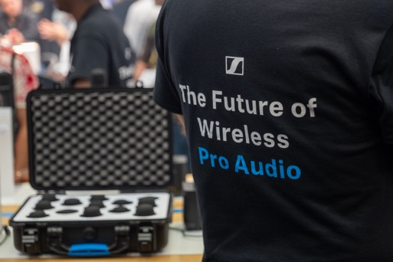**Sennheiser to showcase revolutionary wireless innovations at PLASA Show 2025**

**Experience the groundbreaking Spectera wireless system making its PLASA debut, alongside the SoundBase RF planning tool** **and the complete EW-DX range**

***Wedemark, August 2025* – Global audio specialist Sennheiser is set to showcase an array of cutting-edge solutions at this year's PLASA Show, the UK's premier event for live entertainment technology, featuring products that are widely used across the live events, film, and broadcast industries. Sennheiser's team of experts will be available to guide show visitors through their impressive line-up, including the revolutionary Spectera wideband wireless ecosystem making its PLASA debut, the industry-changing SoundBase RF planning tool, and the proven EW-DX wireless range.**

Visitors to the booth can expect first-hand experience with Sennheiser's Spectera, which has already proven itself in the most demanding RF environments including this year's Glastonbury festival. Using true WMAS (Wireless Multichannel Audio Systems) technology, Spectera represents the world's first wideband, bidirectional digital wireless ecosystem, offering up to 64 channels (32 in/32 out) in a single rack unit with unprecedented control of latency and audio quality. The system's bidirectional bodypacks manage both IEM/IFB and mic/line signals simultaneously, delivering the reliability and flexibility that made it the choice for Arcadia Spectacular's iconic Dragonfly Stage performance.

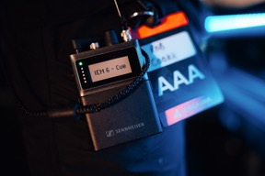For this year’s Dragonfly Stage at Glastonbury, Spectera offered a massive sonic advantage, providing low-latency digital audio to the IEM users and a fast, easy deployment for the crew

​Picture credit: @shotawaydotcom

The SoundBase presentations and demo station at PLASA 2025 will showcase the world’s first brand-neutral RF planning tool and universal wireless audio management software. The app, developed by audio veterans Matt Dale and Donny Kuser, integrates with equipment from all major manufacturers, eliminating the need to switch between multiple applications, particularly during critical production moments. It streamlines wireless coordination, centralises communication, and enables seamless remote collaboration.

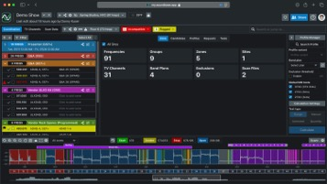Among other solutions from Sennheiser is the complete EW-DX wireless range, part of the Evolution Wireless Digital family, which works seamlessly with SoundBase and includes the new EW-DX EM 4 DANTE receiver. The proven EW-DX wireless microphone system continues to deliver exceptional performance for live sound applications, offering enhanced reliability and audio quality for professional productions.

SoundBase works with wireless systems from every major manufacturer, providing the audio team with a single, time-saving and efficient workflow

Other highlights of Sennheiser's PLASA offering include an expansive selection of microphones available for show attendees to view and test. Featured products include the e 835-S-PTT dynamic cardioid talk-back microphone for live sound engineers and broadcasters requiring instant, reliable voice communication with push-to-activate functionality, and the MD 421 KOMPAKT, which delivers the same superior performance as the original MD 421-II in a multipurpose package with a completely redesigned mounting clip. Last but not least is the Neumann Miniature Clip Microphone System (MCM, for short), which brings true Neumann sound quality to close miking acoustic instruments in live applications.

As part of Sennheiser's 80 years anniversary celebrations, special promotional offers will also be available throughout the show, marking this significant milestone in the company's history of audio innovation.

The complete EW-DX wireless range, including the new EW-DX EM 4 DANTE receiver, will be on show at PLASA 2025

The Sennheiser team, including Kevin Gwyther-Brown (Business Development Manager – Professional Audio), Lee Shuttlewood (Business Development Manager – Professional Audio), Marcus Blight (Technical Application Engineer) and Adrian Reid (Inside Sales Representative), will be on hand to greet show attendees at their booth and will be conducting product demonstrations throughout the event from September 7th to 9th at Olympia London.

“We're excited to connect with industry professionals and demonstrate our latest innovations at our booth D6 at PLASA this year,” says Blight. “From the ground-breaking Spectera system making its PLASA debut to the game-changing SoundBase platform and our proven EW-DX range, we have solutions in store for every professional audio application!”

(Ends)

The images accompanying this media release can be downloaded here.

**About the Sennheiser Brand – 80 Years of Building the Future of Audio**

We live and breathe audio. We are driven by the passion to create audio solutions that make a difference. This passion has taken us from the world’s greatest stages to the quietest listening rooms **–** and made Sennheiser the name behind audio that doesn’t just sound good: It feels true. In 2025, the Sennheiser brand celebrates its 80th anniversary. Since 1945, we stand for building the future of audio and bringing remarkable sound experiences to our customers. While professional audio solutions such as microphones, meeting solutions, streaming technologies and monitoring systems are part of the business of Sennheiser electronic SE & Co. KG, the business with consumer devices such as headphones, soundbars and speech-enhanced hearables is operated by Sonova Holding AG under the license of Sennheiser.

[www.sennheiser.com](http://www.sennheiser.com)

[www.sennheiser-hearing.com](http://www.sennheiser-hearing.com)

**Global Pro Audio Press Contact**

Maik Robbe

maik.robbe@sennheiser.com

+49 (5130) 600 – 1028